Jenkins: Email Authentication

# Double Check

1. That you configured the **“E-Mail Notification”** and **not** the **“Extended E-Mail Settings”**
2. The SMTP server for gmail is : **smtp.gmail.com**
3. The Use SSL button is **Checked**
4. The Use SMTP Authentication button is **Checked**
5. The SMTP port is set to : **465**
6. That You **saved or applied** the configuration
7. That You are **sending** yourTest email **to a valid email**
8. That You are using the **correct email account**

**Note:** The following steps are only valid for **Gmail** Email Accounts

# Gmail with 2-Factor Authentication

Allowing Jenkins to use your Gmail is easy if you have 2-Factor Authentication enabled. **Set up an App Password** for your Jenkins and **use the generated App Password** instead of your normal login password in the Email credentials you give Jenkins.

This is the **Best Option**. It is **Easy to set up**  and **more Secure**. It will also probably **not have any further complications** after the initial setup.

**Follow the tutorial** given at the link below:

<https://support.google.com/accounts/answer/185833?hl=en>

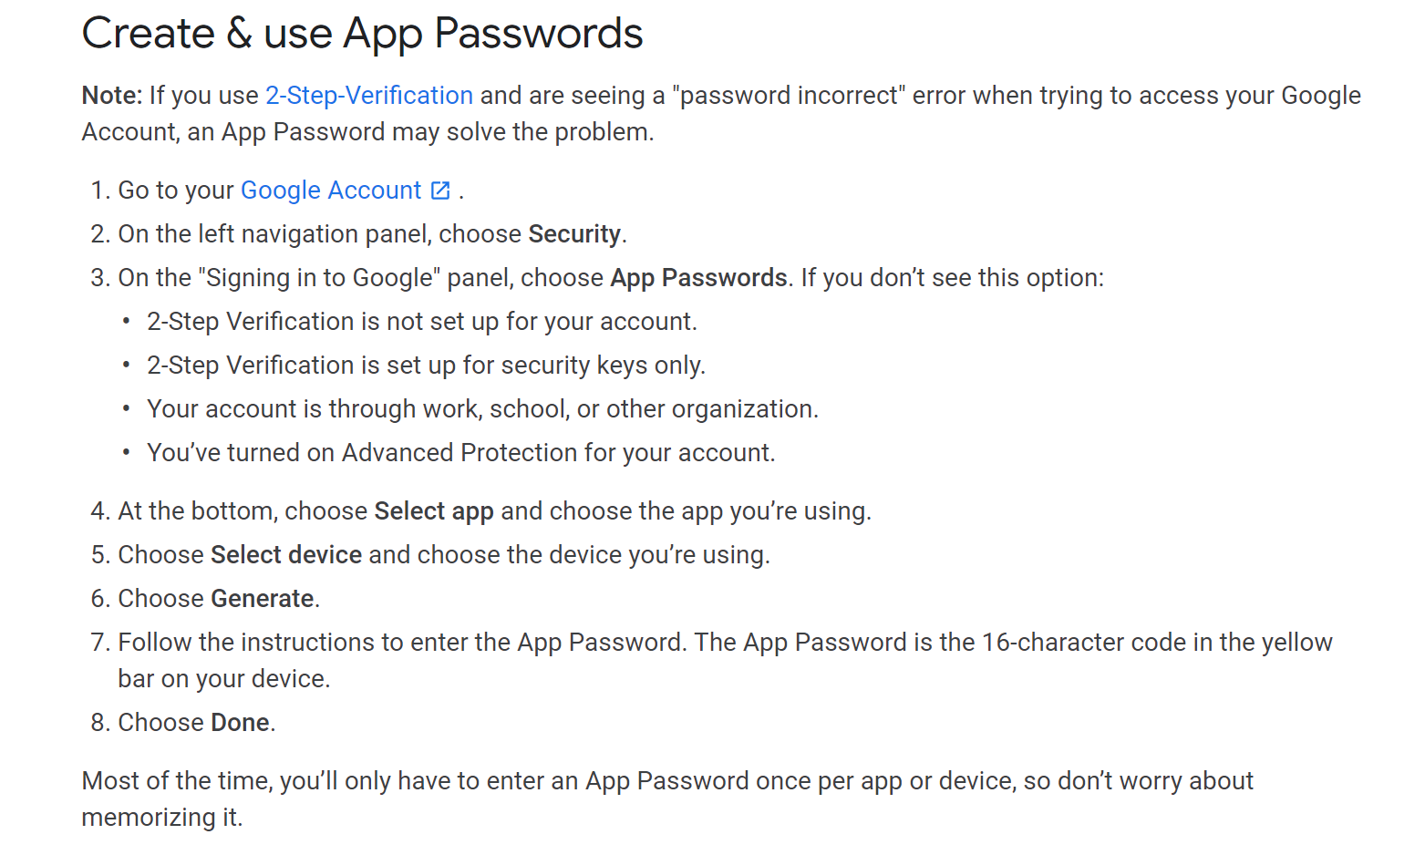

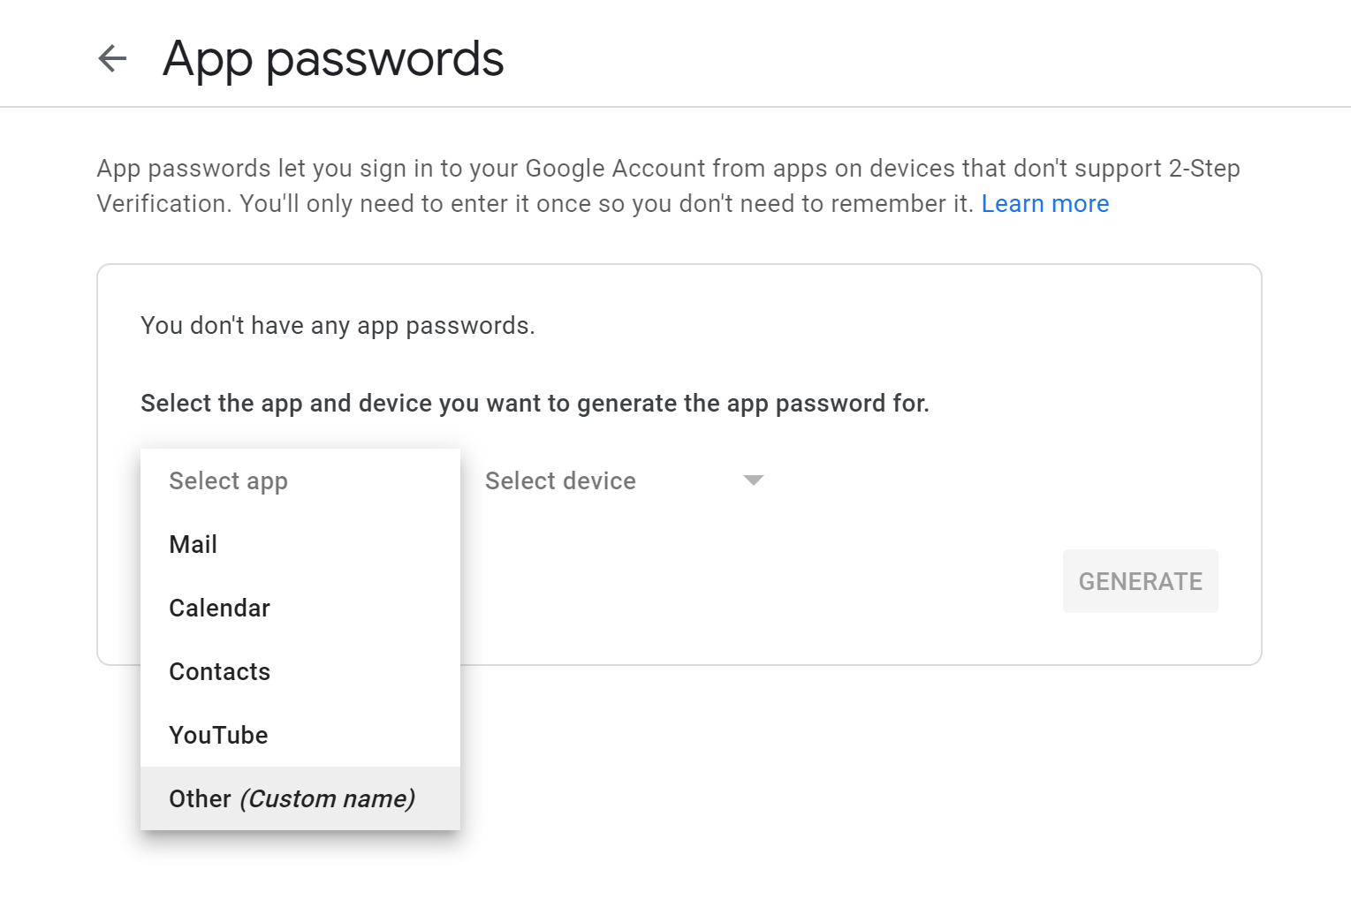

**Note:** For the App selection , use “Other” and type in Jenkins as seen in the screenshots below

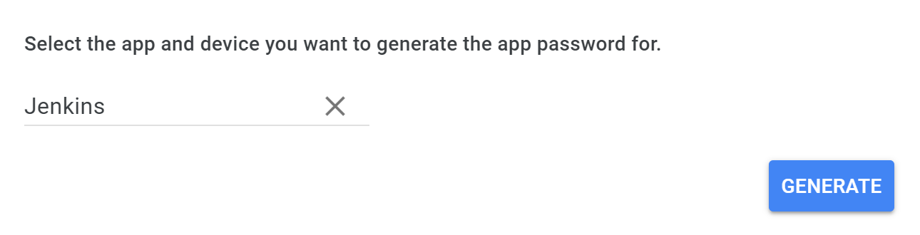

1. After generating your App Password, use it instead of your actual Gmail password in your Jenkins Email Configuration

# Gmail Without 2-Factor Authentication

To allow Jenkins to use your gmail without 2-Factor Authentication, you will **need to allow “Less secure apps”** to use your gmail account

You can allow it by being signed into the gmail you are using and **clicking the link below:**

* 1. <https://myaccount.google.com/lesssecureapps>

1. After you allow less secure apps, **Google will send you an alert.**  You **NEED TO: NAVIGATE** to the email and **CHECK ACTIVITY** , then **CONFIRM** THAT IS WAS YOUotherwise google will revert back to not allowing Jenkins to use your email.

The authentication steps are shown below



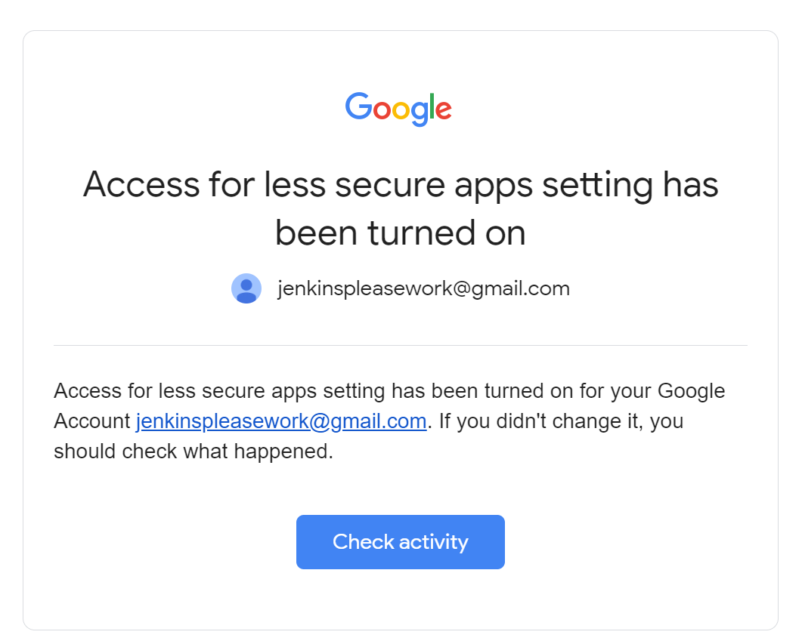

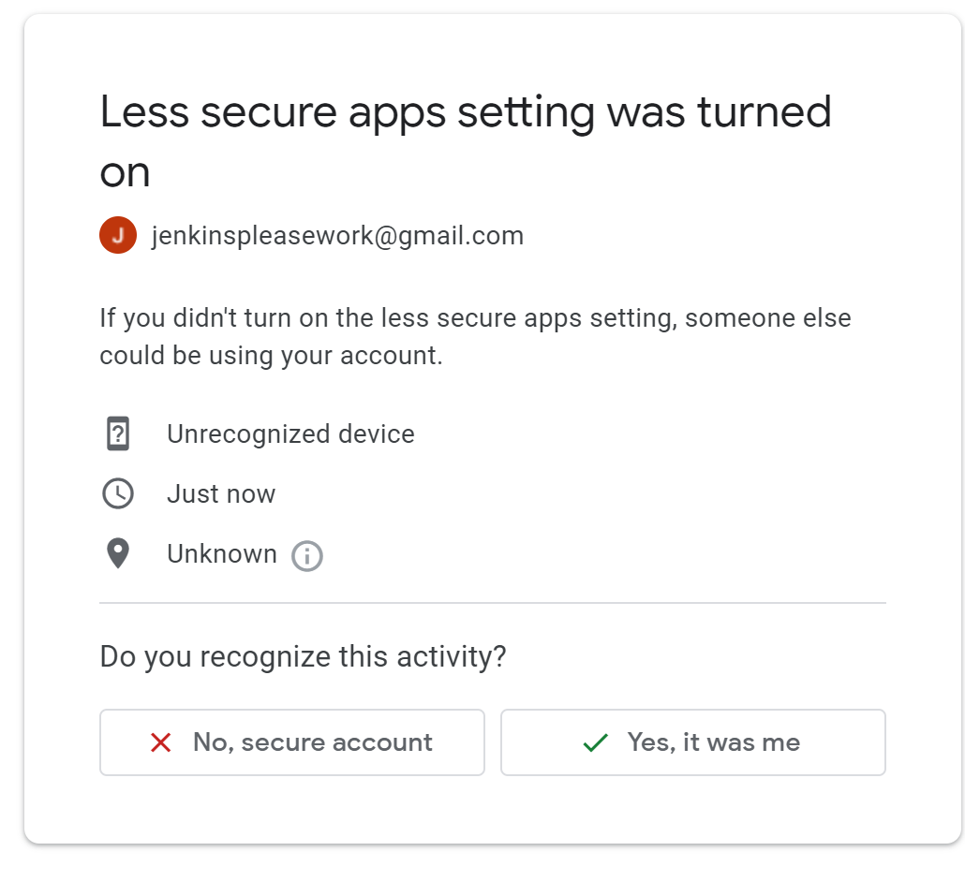

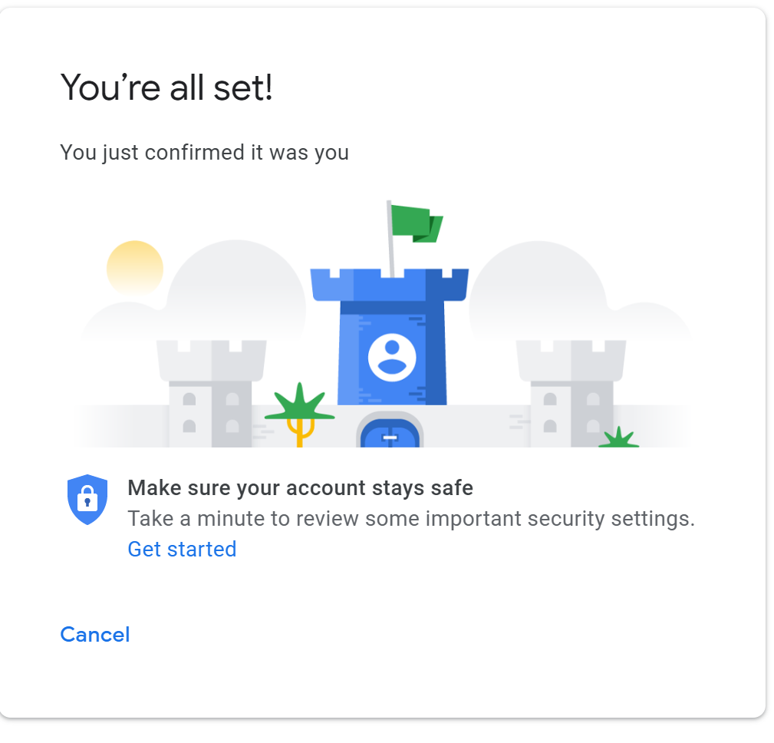

1. If the steps above didn’t work you may **need to do a UnlockCaptcha** This is found at the link below:
   1. <https://accounts.google.com/b/0/DisplayUnlockCaptcha>
2. If these steps are not working**, I would suggest enabling 2-Factor Authentication.** This allows Jenkins to securely access your Gmail using an : **App Password**
   1. If you decide to set up 2-factor authentication follow the tutorial posted below.
   2. You can disable 2 Factor Authentication afterwards.

# How To Set-Up 2-Factor Authentication

**Note:** You can disable 2 Factor Authentication afterwards.

Follow the steps given in the google tutorial below:

<https://support.google.com/accounts/answer/185839?co=GENIE.Platform%3DDesktop&hl=en>